GUVI TASK 20

1. For this task first open a AWS ec2 instance using ubuntu AMI with instance type t2.micro

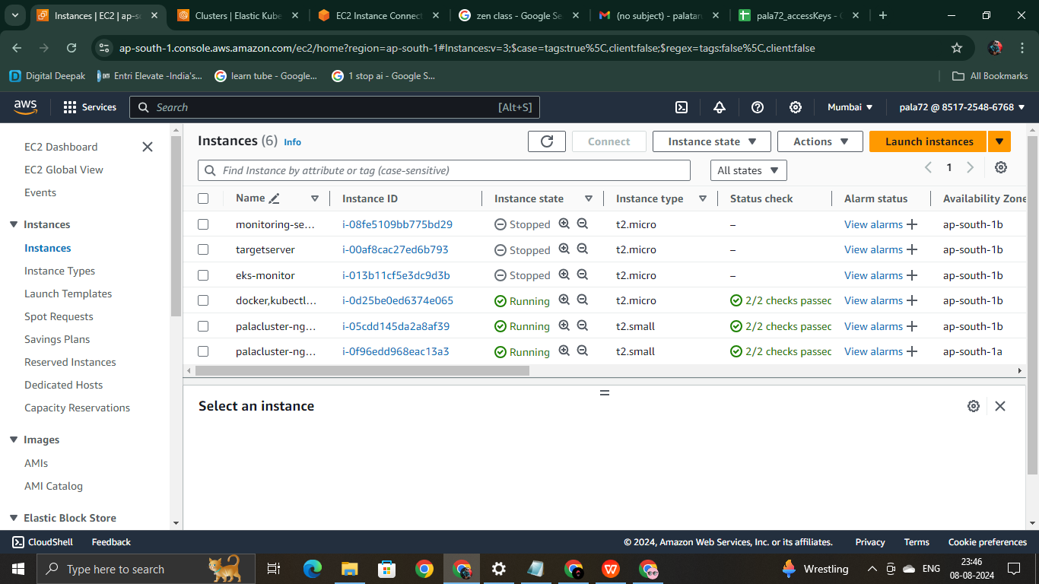

that fourth instance is the instance I have created

1. Next open that instance and connect it.
2. Update the packages and install docker,kubectl,eksctl
3. Open security port 80,443,8080 .

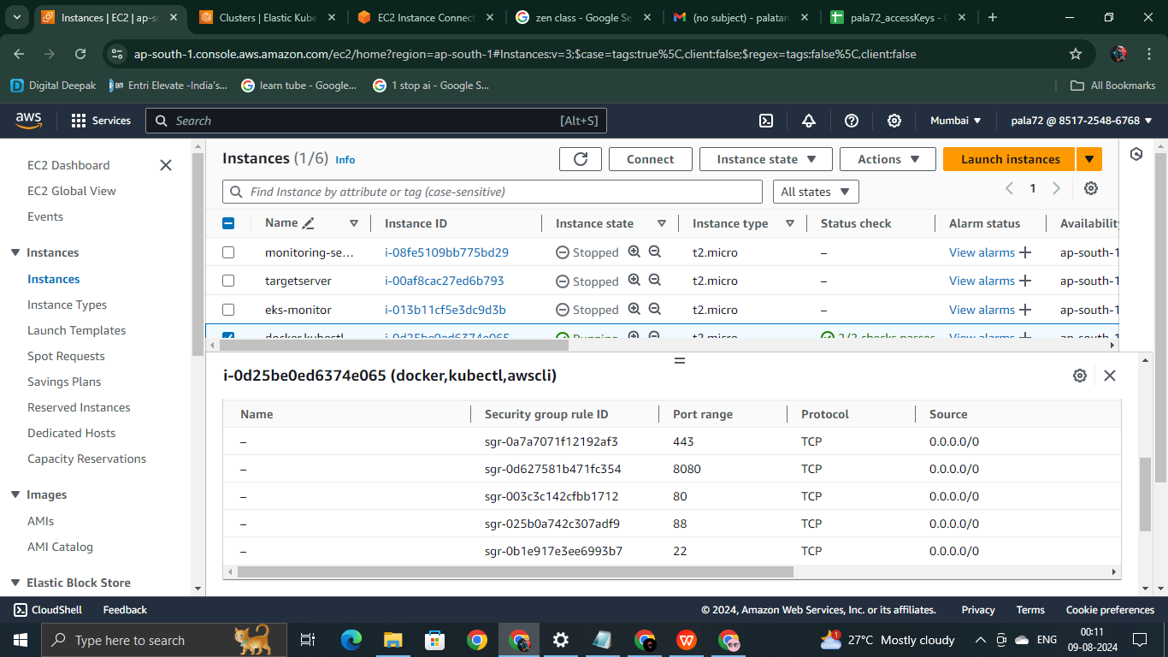

1. Next create a eks cluster with the cluster create syntax

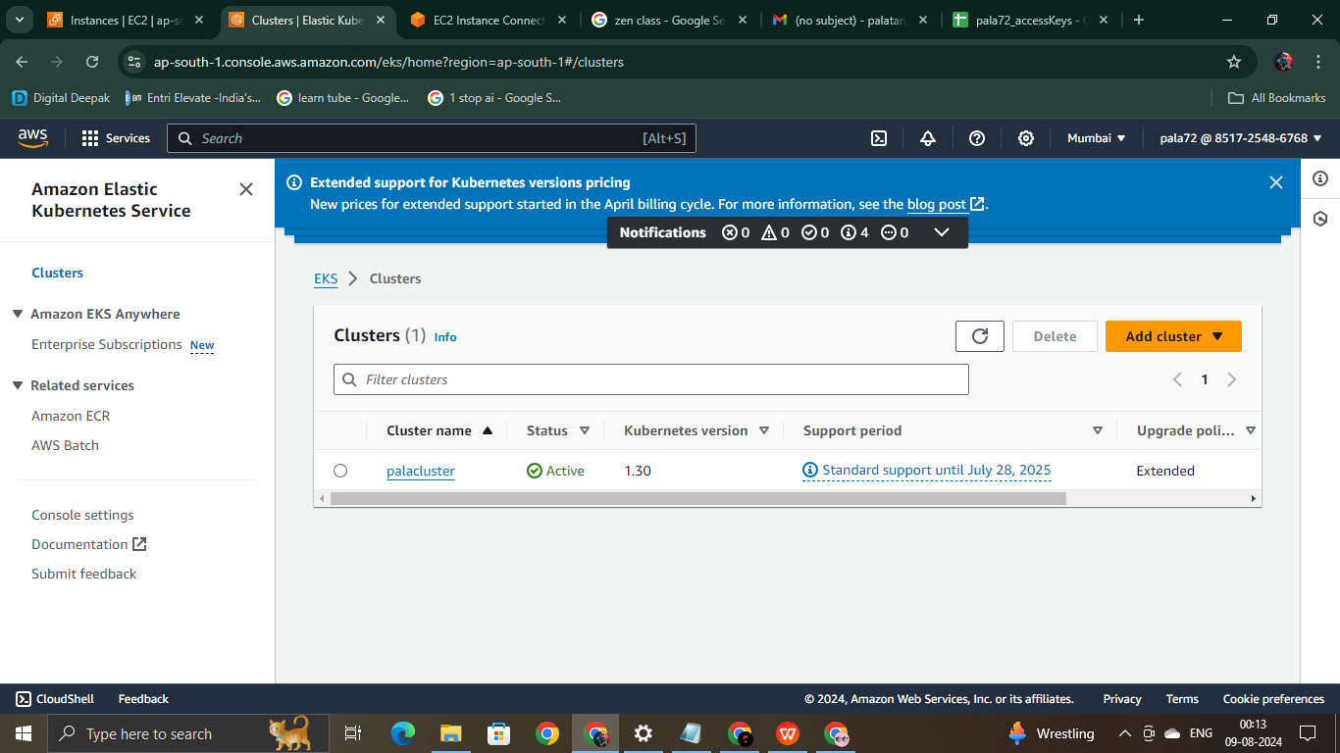

1. Also configure your AWScli by giving the access key, secret key, default region, File name.
2. Next give details for your application. I am using a simple python flask application
3. Create a file called app.py using vi editor and save it.
4. Create a dockerfile
5. Next login your docker using login credentials

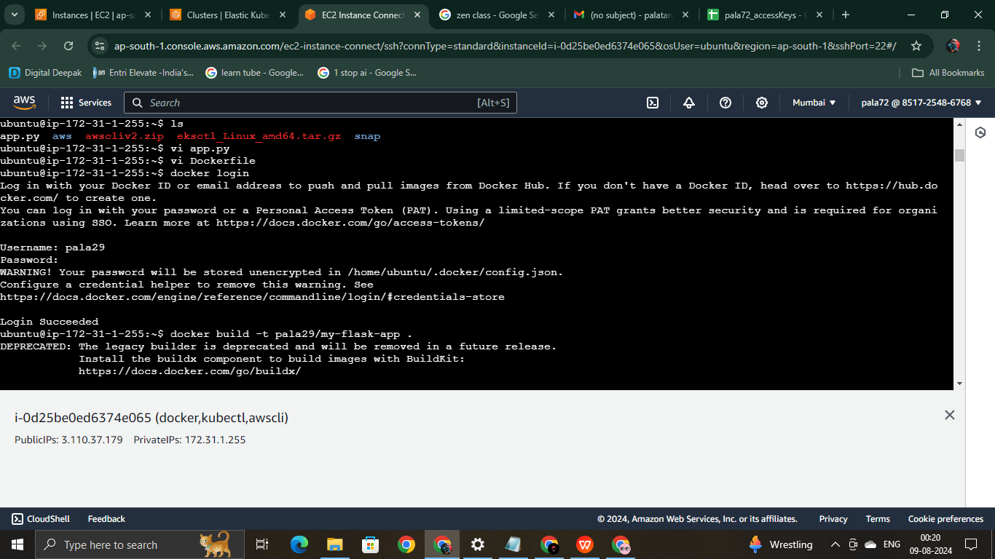

1. Do docker build and docker push by giving correct name to it

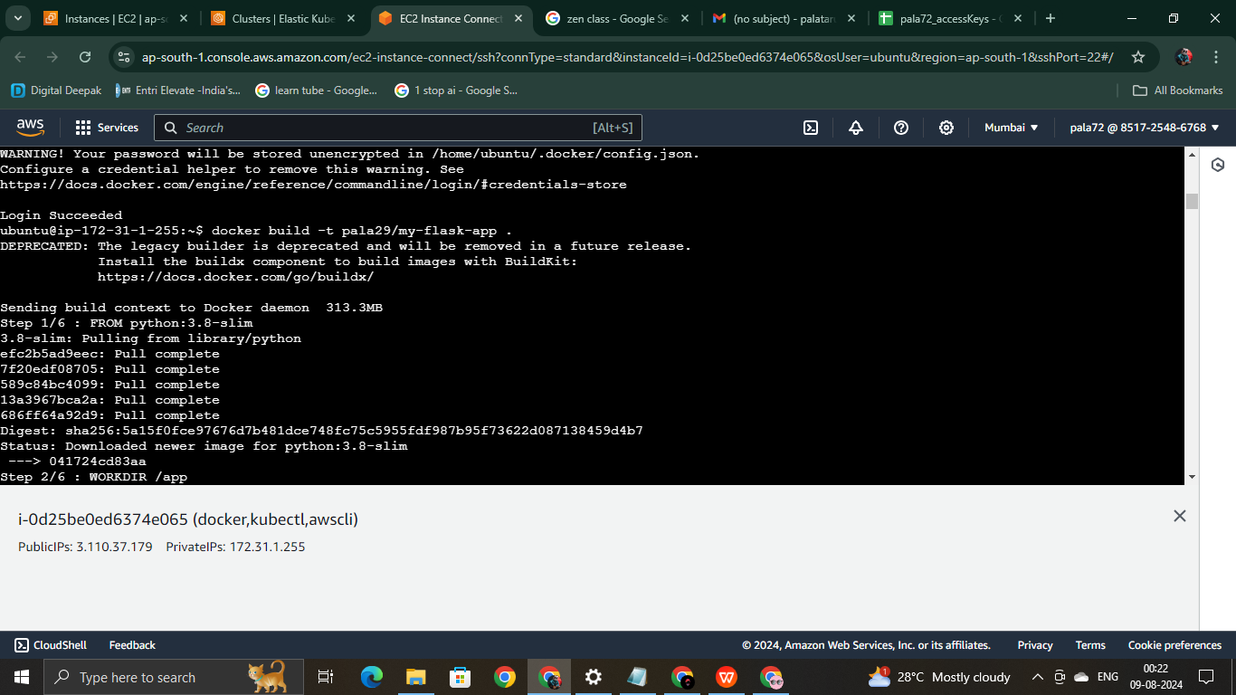

1. Next two files deployment.yaml and service.yaml

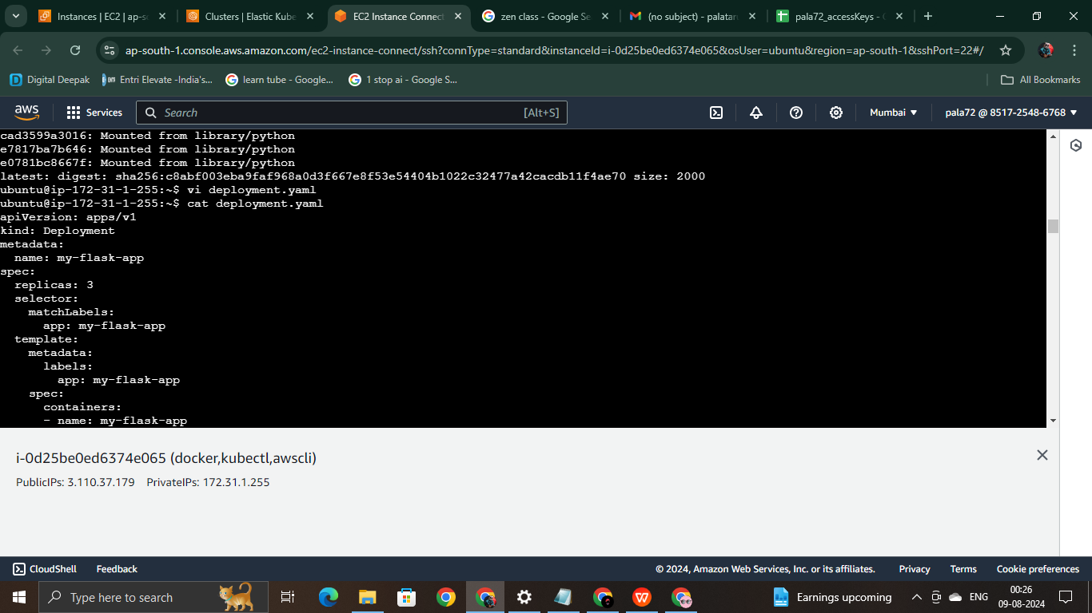

1. Deploy the application with the deploy command.

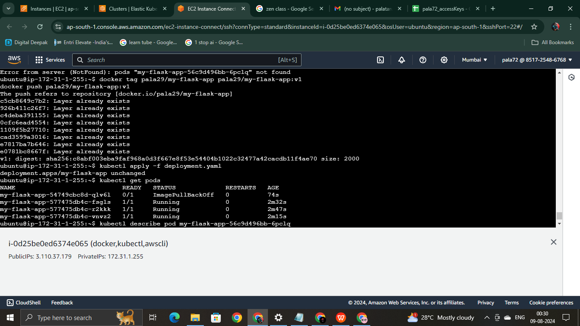

1. that’s it next open your external IP so the applicationn runs.

-----X-----